***2nd Sunday in Ordinary Time***

A favorite breakfast place in our town brags about its choice of twenty different jellies and jams for your morning toast, 8 different types of coffee and at least 20 different combinations of eggs, home fries, and meat. The owners say, “If you can’t find something good to eat here, you won’t find something good anywhere!” If nothing else, variety is the spice of breakfast!

The Holy Spirit comes to everyone, but not everyone receives the same gifts. We are all different, capable of offering to the church a unique gift, ability or talent. God’s grace allows us to make His gifts our own so that we can complete the mission entrusted to us. It is the perfect blend of divine grace and human nature, all given by God. In teaching, healing, forgiving and preaching, we bring the Gospel message in a unique way to all those we meet.

Community—church—can be an untidy thing. It would be easier if everything were more predictable, more stable and more acceptable. Gifted in so many ways, the Church must reach out to all people and places, in ways and means we may not fully understand or appreciate. Let’s give others the benefit of the doubt. Allow their gifts to be used so that the Gospel can be proclaimed to all people, even those who hear us.

*~James Gaffney © Pilot Bulletins*

COR AREA CATHOLIC COMMUNITY

Saint Charles, Herman Our Lady of the Runestone Saint Olaf, Elbow Lake

61 Berlin Ave. S, Herman, MN 56248 11 Runestone Dr., Kensington, MN 56343 518 Division St. E, Elbow Lake, MN 56531 320-677-2433 [stcharles@runestone.net](mailto:stcharles@runestone.net) 320-965-2596 [olroffice@runestone.net](mailto:olroffice@runestone.net) 218-685-5372 [stolaf@runestone.net](mailto:stolaf@runestone.net)

Website: [www.stolafelbowlake.org](http://www.stolafelbowlake.org/)

**SECOND SUNDAY IN ORDINARY TIME l JANUARY 19, 2025**

**Weekend Mass Schedule**

**Saturday 5:00 pm St. Charles (odd months) Sunday 8:30 am Our Lady (even months)**

**10:30 pm St. Olaf**

**Sacrament of Reconciliation**

**30 Minutes before all weekend Masses & 7:00 PM on Tuesdays at St. Olaf**

#### Pastor

Fr. Jose Chettoor

218.685.4318 [jchettoor@gmail.com](mailto:jchettoor@gmail.com)

## MASS SCHEDULE & INTENTIONS

**MASS SCHEDULE & INTENTIONS**

#### Saint Charles, Herman

**2nd Sunday in Ordinary Time**

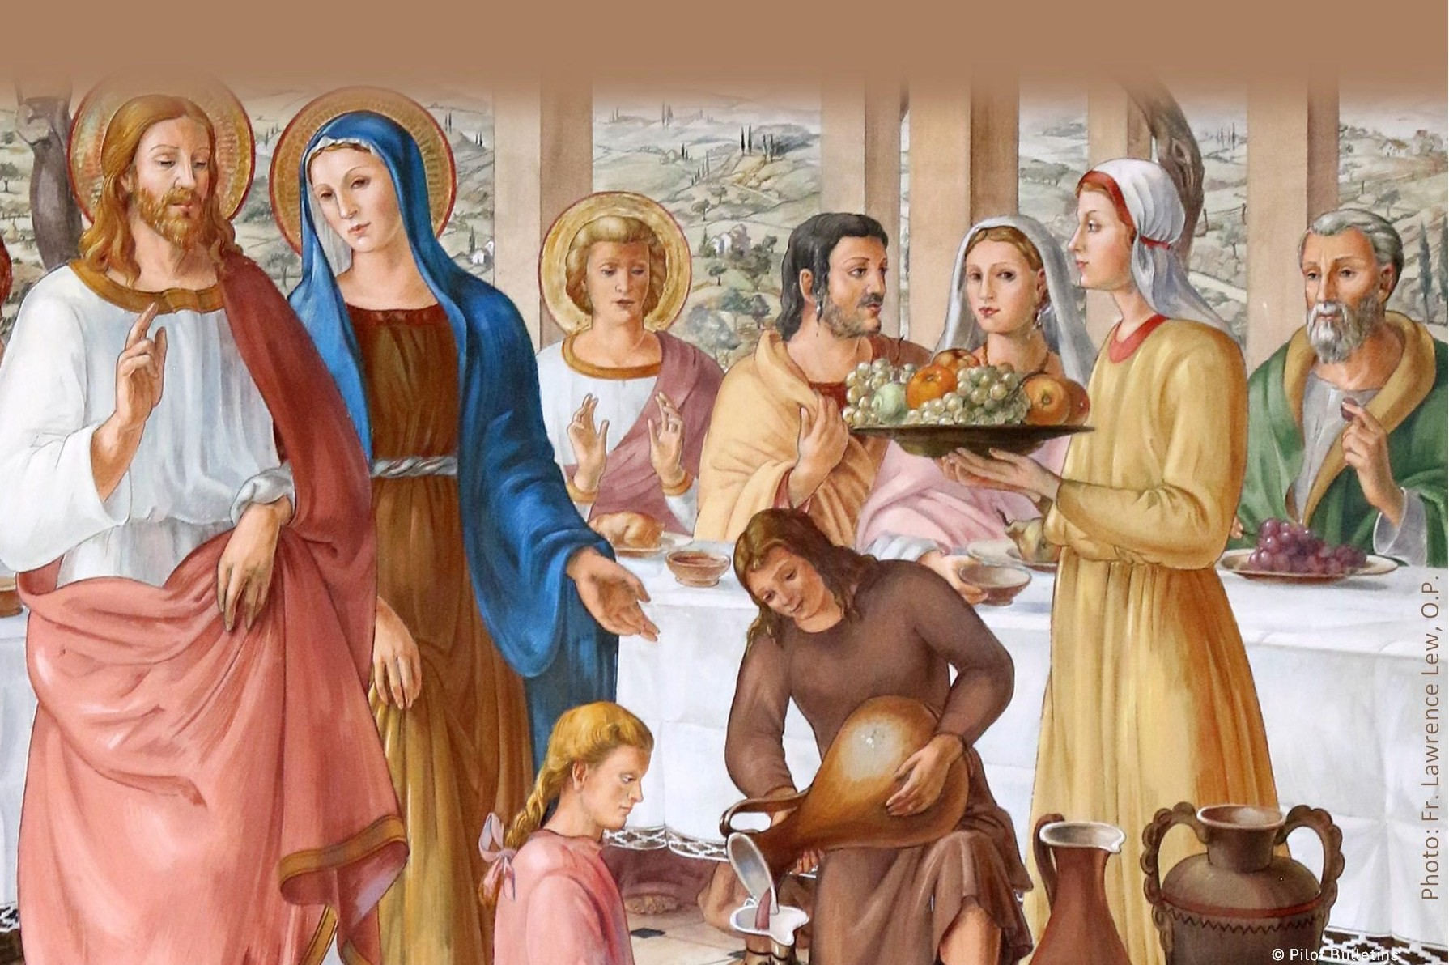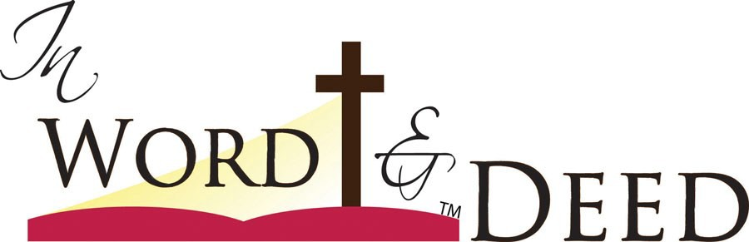

When my five-year-old nephew and his grandmother went out for an early morning walk, they returned to find the door locked and Grandmom’s keys inside. Before Grandmom could figure out what to do, Aidan ran behind the house and a moment later, the front door opened. He had crawled though the doggy door and opened the door, clearly pleased with himself for thinking of such a clever solution.

When God handed out talents and abilities, He was generous. Everyone has something and everyone can contribute. People tend to judge others or dismiss them because of some external quality that does not fit their expectations. But like any great gift, you cannot judge it by the way it is wrapped. Sometimes, when we are willing and our minds are open, we can discover treasures in places we would never expect.

Some people are just waiting for the chance to share their gifts. When the right time and opportunity comes along, they will shine, often exceeding anyone’s expectations, including their own. The family is the first place where we should be able to share, to feel important and to make a contribution. In daily routines, special events or holiday celebrations, there are lots of opportunities for everyone to contribute. With love, support and a bit of encouragement, we can all be our best!

*~James Gaffney © Pilot Bulletins*

**Saturday January 18**

5:00 pm For the people of the ACC

**Thursday, January 23**

8:30 am +Stan Vipond **3rd Sunday in Ordinary Time Saturday January 25**

5:00 pm Special intention

#### Our Lady of Runestone

**Sunday, January 19**

8:30am +Eugene Schneider

**Wednesday, January 22** 8:30 am +Don Lardy **Sunday, January 26**

8:30am +Nathan Schneider

#### Saint Olaf, Elbow Lake

**Sunday, January 19**

10:30 am Special intention

**Tuesday, January 21**

7:30 pm +Minnie Neubauer

**Friday, January 24**

7:15 am +Bev Liebl

**Sunday, January 26**

10:30 am People of the ACC

### LIFE GIVING BRIDEGROOM

Dear friends,

Throughout the Bible, marriage is the symbol of the

covenant relationship God desires with His chosen people. God is the Groom, humanity His beloved and sought-after bride.

Jesus performs His first public "sign" at a wedding feast. By changing water into wine, Jesus revealed his glory at Cana. Wine in abundance is a sign. The changing of six stone jars of water, each holding twenty to thirty gallons, into good wine was a sign which manifested God’s overflowing

generosity. God gave himself lavishly for his lowly creature, man through Incarnation. God’s sign is overflowing

generosity. The superabundance of Cana, therefore, is a sign that the hour of God’s marriage feast with his people has begun in the coming of Jesus.

The abundance of good wine that Jesus made at the wedding of Cana was a sign of the gift of the Holy Spirit given to His bride and body.

Fr. Jose

**Saint Charles, Herman**

**ACC Announcements**

**Saint Olaf, Elbow Lake**

**Our Lady of Runestone**

**“FREE** – Men and women, young and old,

strengthen and grow in your faith for your families with five short videos produced by the *Knights of Columbus* called the “**Mission of The Family**”. The videos can be found on the *Knights of*

*Columbus* website for free! Here is the link and QR Code to find **“The Mission of The**

**Family”** videos**:** [**https://www.kofc.org/en/**](https://nam02.safelinks.protection.outlook.com/?url=https%3A%2F%2Fwww.kofc.org%2Fen%2Fcampaigns%2Finto-the-breach.html&data=05%7C02%7CBarb.Simon-Johnson%40gw.stcdio.org%7Cbf55729f5e624365096008dd33ffd9ee%7C380e4089e12a4ce4b6735d2ee7e28d72%7C0%7C0%7C6387238961)[**campaigns/into-the-breach.html**](https://nam02.safelinks.protection.outlook.com/?url=https%3A%2F%2Fwww.kofc.org%2Fen%2Fcampaigns%2Finto-the-breach.html&data=05%7C02%7CBarb.Simon-Johnson%40gw.stcdio.org%7Cbf55729f5e624365096008dd33ffd9ee%7C380e4089e12a4ce4b6735d2ee7e28d72%7C0%7C0%7C6387238961)

The five videos are less than 14 minutes in length. You can also find the original “Into The Breach” video series by rolling down on this

webpage and under CATEGORIES click on “Into The Breach”. This series is also free of charge and is sure to help you grow in your faith.”



#### Worldwide Marriage Encounter Weekend:

Worldwide Marriage Encounter emphasizes

communication between husband and wife, who spend a weekend together away from the

distractions and the tensions of everyday life, to concentrate on each other.

It's not a retreat, nor a marriage clinic, nor group

sensitivity. It's a unique approach aimed at revitalizing Christian Marriage.

The next available **Weekends** are Apr 5-6, 2025 in

BRAINERD, MN and Nov 22-23, 2025 in ALEXANDRIA,

MN. Early registration is highly recommended. For more information, visit **northmnwwme.org** or

contact Miki at [applications@northmnwwme.org](mailto:wmandbethnickles@hotmail.com) or 507-227-8229.

# Liturgical Ministers

**Saturday, January 25th 5:00 pm Lector:** Mike Backman

**Sacristan:** Kim Hanson

**Servers:** Addison Blume & Maggie Vlaminck

**EMHC:** Julie Oachs & Larry Vipond

**Gifts:** Kara Claassen family

**Ushers:** Matt Drewicke & Bob Werk

# Stewardship

January 11, 2025: (will be in the next bulletin)

# Announcements

**2024 CONTRIBUTION STATEMENTS** are on the

table in the entryway ready to be picked up. Thank you for your generosity.

### 2025 DONATION ENVELOPES

Please pick up your donation envelope box if you haven’t done so already.

### SNOW SHOVELING SIGN UP

Please consider helping out this winter by volunteering your time. Sign up sheets are on the

table in the entry way. Lots of empty spots for the rest of the snow season.

#### AVE MARIA PARISH IN WHEATON ANNUAL PANCAKE & SAUSAGE BREAKFAST is held on

Sunday, January 19th 9:30-noon. Free will offering.

### EUCHARISTIC ADORATION:

Thursdays 7:00 am - 8:30 am

# Prayer List

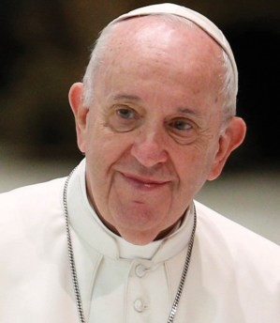

**Pope Francis’ Prayer Intention for January:**

**For the right to an education**

Let us pray for migrants, refugees, and those affected by war, that

their right to an education, which is necessary to build a better world, might always be respected.

**Please remember the following in your prayers:** Marie Henderson, Morgan Ptacek, McCoy Jipson, Jeanne Backman, Delores Jones, Jace Pederson. Remember to pray for and visit those in the area nursing homes, assisted living centers and the

homebound.

# Liturgical Ministers

**Sunday, January 26th 8:30 am Lector:** Judy Swanson

**Ushers:** Keith Swanson & Bill Eisel

**Gifts:** Thomas & Angela Goetz

# Stewardship

January 12, 2025: Adult & plate $642.00

# Announcements

#### Coffee & Rolls Sunday—January 26th.

**Online Contribution:** If you would like to contribute to O L R online, the link is [https://](https://www.osvhub.com/our-lady-of-the-runestone/funds) [www.osvhub.com/our-lady-of-the-runestone/](https://www.osvhub.com/our-lady-of-the-runestone/funds) [funds](https://www.osvhub.com/our-lady-of-the-runestone/funds)

# Prayer List

#### Please remember the following in your prayers:

Jeanne Stamness, Megan Lardy, and Bill Lannoye.

**Diocesan Festival of Families:** Don’t miss out!

Registration is filling fast. Join hundreds of others to celebrate the role of family and enjoy activities specifically designed for you! Get to know other

families from around the diocese and grow in faith as a family. The cost is only $25 for your family!

For more information and to register go

to: https://stcdio.org/event/2025-festival-of- families/

**Stewardship as a Way of Life:** “To each individual the manifestation of the Spirit is given for some benefit.” – 1 Corinthians 12:7

St. Paul tells us that God has blessed each of us for a reason. How has God blessed you? Are you using your gifts according to God’s plan? How are you helping to build God’s kingdom here on

earth? Remember that if you don’t do the work God planned for you, no one else can do it. Live the life God has intended for you. Take time to discern your charisms (gifts from the Holy

Spirit). Experience the supernatural Peace and Joy God desires for each of us.

**Mass Intentions:** If you would like to have a Mass offered for someone living or deceased, please fill out a Mass Intention envelope and leave it in the collection basket or mail it to the church. The suggested donation is $10.00.

# Liturgical Ministers

#### Sunday, January 26th 10:30 am

**Servers:** Aaron Biss, Landyn Johnson, Jayce McNamara

**Rosary:** Marlys Jennen

**Sacristan**: Debi Anderson

**Ushers**: John and Chris Van Kempen

**Lector**: Laurie Haberer

**Gifts**: Kevin Schill family

**EMHC:** Debi Anderson, Kate Jennen, Lorna Johnson

**Coffee/Rolls**: John/Brenda Fischer, Marsha Frikken

# Stewardship

January 12, 2025: Adult & plate $1032.00

Coffee/rolls $6.00

# Announcements

#### 2024 CONTRIBUTION STATEMENTS are in your

**mailboxes.**

**AA GROUP:** AA Group meets Thursdays at 7:00 pm at Bethlehem Lutheran Church, Elbow Lake. Contact Tony with questions 952-239-3401.

### EUCHARISTIC ADORATION:

Tuesdays 6:30 pm - 7:30 pm

# Prayer List

**Please remember the following in your prayers:**

Mary Wellnitz, Dorothy Hermes, Jace Grende, Karla Wohlers, Archie Moeller, Karin Johnson, Janice Johnson and Dennis Dugan.

**What is Ordinary Time?**

Ordinary Time , meaning ordered or numbered time, is celebrated in two segments: from the Monday

following the Baptism of the Lord up to Ash Wednesday; and from Pentecost Monday to the First Sunday of Advent. This makes it the largest season of the Liturgical Year.