**CATHOLIC CUSTOMS & TRADITIONS**

# Epiphany Blessing

The Epiphany household blessing is an ancient practice in the Church. This tradition is a beautiful way to observe the coming of the Magi while invoking God’s blessing on your home and all who enter it. The blessing can be done with holy water or by marking with a blessed chalk the inside of the main door with the Magi code and the current year connected with cross.

There are a few different formulas for blessing out there, but the essence of the ritual is always the same: a priest or the head of the household calls down God’s blessing on the house and everyone who comes into

it, and an inscription is made above the door in chalk.

The inscription reads: the first two digits of the year + C + M + B + the last two digits of the year connected with crosses. The initials C, M and B signify the Latin phrase *Christus mansionem benedicat*: “May Christ bless the house.” They also represent the names of the magi — Caspar, Melchior and Balthasar. The Epiphany blessing for current year will be 20 + C + M + B + 25

## COR AREA CATHOLIC COMMUNITY

Saint Charles, Herman Our Lady of the Runestone Saint Olaf, Elbow Lake

61 Berlin Ave. S, Herman, MN 56248 11 Runestone Dr. , Kensington, MN 56343 518 Division St. E, Elbow Lake, MN 56531 320-677-2433 [stcharles@runestone.net](mailto:stcharles@runestone.net) 320-965-2596 [olroffice@runestone.net](mailto:olroffice@runestone.net) 218-685-5372 [stolaf@runestone.net](mailto:stolaf@runestone.net)

## THE EPIPHANY OF THE LORD l JANUARY 5, 2025

### Weekend Mass Times

**Saturday 5:00 pm St. Charles (odd months) Sunday 8:30 am Our Lady (even months)**

**10:30 pm St. Olaf**

### Sacrament of Reconciliation

**30 Minutes before all weekend Masses &**

**7:00 PM on Tuesdays at St. Olaf**

#### Pastor:

Fr. Jose Chettoor

218.685.4318 [jchettoor@gmail.com](mailto:jchettoor@gmail.com)

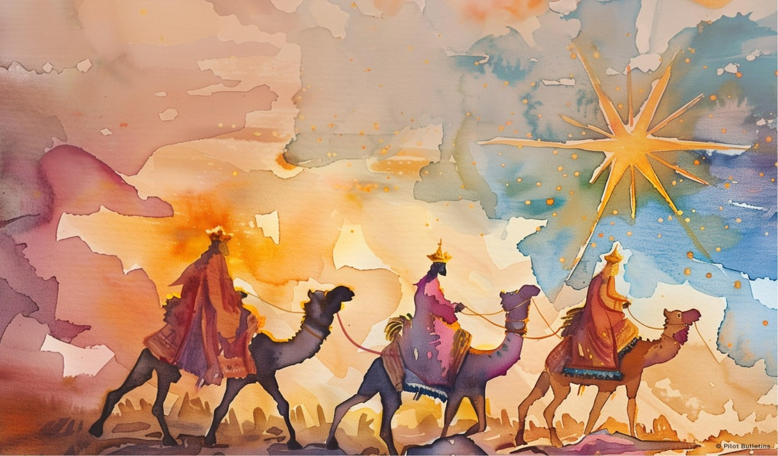

# Epiphany

A Global Positioning System (GPS) is a great device to have on a journey. It gives accurate directions and helps the driver navigate unfamiliar territory. With some models, however, it is important to use your computer to update its maps. Otherwise, you might end up short of your destination or taking a very long route to get there—if you get there at all.

The Magi undertake a long and difficult journey because they are convinced that the star they see is of Divine origin. Their GPS is the Glorious Power of a Star and it serves to lead them to Bethlehem where they see the Holy Infant. By their actions, they acknowledge this special Child and leave their gifts of gold, frankincense and myrrh. Theirs was a successful journey.

We’re all on a journey of faith and in need of guidance. Our GPS is the Great Power of our Savior. He becomes the Way, the Truth and the Light, leading us on the path to eternal life. Make sure you update frequently. Prayer, Scripture, Sacraments and good deeds will keep us in contact with Him, enabling us to recognize Him wherever He may lead us.

*~James Gaffney, © 2009 Karides Lic. to Pilot Bulletins*

**MASS SCHEDULE & INTENTIONS**

#### Saint Charles, Herman

**The Epiphany of the Lord Saturday January 4**

5:00 pm +Ralph Kieley

**Thursday, January 9**

No Mass

**The Baptism of the Lord Saturday January 11**

5:00 pm +Alan & +Michelle Werk

#### Our Lady of Runestone

**Sunday, January 5**

8:30am People of the ACC

**Wednesday, January 8**

No Mass

**Sunday, January 12**

8:30am +Bill Murray

#### Saint Olaf, Elbow Lake

**Sunday, January 5**

10:30 am +Louis and +Phyllis Frikken

**Tuesday, January 7**

No Mass

**Friday, January 10**

7:15 am +Laura Williams

**Sunday, January 12**

10:30 am People of the ACC

#### WHAT GIFT DO YOU OFFER TO JESUS?

Dear friends,

Epiphany is the feast of the manifestation of Jesus Christ to the world, mainly through the visit of the Magi. The Magi from the East came to adore the newborn king and to offer him royal

gifts of Gold, frankincense, and myrrh, each representing different aspects of Christ’s identity: gold for his kingship,

frankincense for his divinity, and myrrh for his humanity and future suffering.

The manifestation of Christ to the world shows that salvation is extended to all in Christ. No one is excluded from God's love. Christ is the light of the world.

The Epiphany of the Lord calls us not only to worship Jesus as the promised Christ but also to offer him the kinds of gifts that will reveal him to the world. It is through faith, hope, and

charity that we can best manifest Christ as the light of the world. May we, like the Magi, seek the Lord with open hearts and offer our unique gifts to bring happiness, healing, and hope into the lives of our brothers and sisters.

Fr. Jose Chettoor

**Mass Cancellation:** There will be no weekday Masses this Tuesday, Wednesday and Thursday, January 7-9 as Fr. Jose will be attending priest’s retreat at Christ the King R C in Buffalo MN.

**Saint Charles, Herman**

**ACC ANNOUNCEMENTS**

**Saint Olaf, Elbow Lake**

**Our Lady of the Runestone**

### Inglese_V1Jubilee 2025

**ACC ANNOUNCEMENTS**

The Jubilee of 2025 began on December 24, 2024, with the opening of the Holy Door in Rome by Pope Francis and will last until January 6, 2026.

The opening of the Holy Door during the Jubilee symbolizes the passage that every Christian must make from sin to grace.

The Jubilee is a special year of grace when the Catholic

Church offers the faithful the chance to receive the

plenary indulgence, meaning the forgiveness of sins for themselves or deceased relatives.

The Jubilee Logo shows four stylized figures to

indicate all of humanity from the four corners of the earth. They are each embracing another, indicating the solidarity and brotherhood that must unite peoples. It should be noted that the first figure is clinging to the cross. The underlying waves are choppy to indicate that the pilgrimage of life is not always on calm waters. Oftentimes personal

circumstances and world events call for a greater

sense of hope. This is why the lower part of the Cross is elongated turning into an anchor, which dominates the movement of the waves. As is well known, the anchor has often been used as a metaphor for hope.

In fact, in maritime jargon, the hope anchor is the name given to the spare anchor, used by vessels for emergency maneuvers to stabilize the ship during

storms. It should be noted that the image shows how the pilgrim's journey is not individual, but rather communal, with the signs of a growing dynamism that moves more and more toward the Cross. The Cross is by no means static, but it, too, is dynamic, bending toward and meeting humanity as if not to

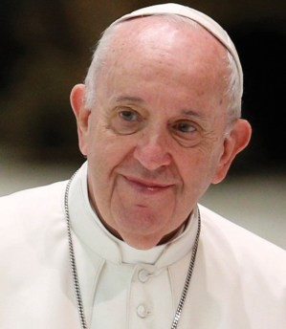

**Pope Francis’ Prayer Intention for January:**

**For the right to an education**

Let us pray for migrants, refugees, and those affected by war, that their right to an education, which is

necessary to build a better world, might always be respected.

leave it alone, but rather offering the certainty of its presence and the reassurance of hope. Finally, the Jubilee 2025 Motto, *PILGRIMS OF HOPE* is clearly

visible in the color green.

Just as the jubilee logo features “four stylized figures, representing all of humanity, coming from the four corners of the earth,” people are encouraged to

pilgrimage across the diocese serving as beacons of

hope ignited by prayers and actions.

### Liturgical Ministers

**Saturday, January 11th 5:00 PM Lector:** Tim Backman

**Sacristan:** Drewickes

**Servers:** Amelia Vlaminck & Kimmy Kerzman

**EMHC:** Lisa Engquist & Joan Kirkeide

**Gifts:** Dana & Katy Blume

**Ushers:** Matt Drewicke & Bob Werk

### Stewardship

December 24, 2024: Adult & plate $1829.00

Youth $53.00 December 29, 2024: Adult & plate $935.00,

Youth $16.00; Christmas $100.00

### Announcements

#### 2025 DONATION ENVELOPES & CALENDARS

Please pick up your donation envelopes and calendar if you haven’t done so already.

#### SNOW SHOVELING SIGN UP

Please consider helping out this winter by volunteering your time. Sign up sheets are on the table in the entry way.

### Prayer List

**Please remember the following in your prayers:** Marie Henderson, Morgan Ptacek, McCoy Jipson, Jeanne Backman, Delores Jones, Jace Pederson.

### Liturgical Ministers

**Sunday, January 12th 8:30am Lector:** Angela Goetz

**Ushers:** Jeff Schneider & Ben Dostal

**Gifts:** Schneiders

### Stewardship

December 25, 2024: Adult $2350.00 Loose $571.00 December 29, 2024: Adult $800.00 Loose $172.00 Christmas $200.00; Christmas flowers $60.00

### Announcements

#### Thanks to all who donated Money for the Christmas Flowers.

**Special Memorials are:** Mary Hoffmann - Ron Giese, Noah Goetz - Kelly McCann – Joe & Laura

Faber Holmes, Anderson, Hawk, & Olson Families Bill & Mary Murray - Don Robertson - Debra Moen Eugene, Tammy & Nathan Schneider – All family gone before us, Don Lardy – Tanya Hoekstra

**Coffee & Rolls Sunday—January 26th.**

### Prayer List

#### Please remember the following in your prayers:

Jeanne Stamness, Megan Lardy.

### Liturgical Ministers

#### Sunday, January 12th 10:30am

**Our Lady of the Runestone**

**Servers:** Whitney Blume, Dylan Johnson, Kendall Marks

**Rosary:** Lorna Johnson

**Sacristan**: Tim Johnson **Ushers**: Children & Youth **Lector**: Children & Youth **Gifts**: Children & Youth

**EMHC:** Charlene Blume, Tim Johnson, Andrew Marks

**C/Rolls:** S/H Wevley, S/C Long

### Stewardship

December 24, 2024: Adult & plate $2172.00 December 29, 2024: Adult & plate $1035.00

Coffee & rolls $19.75

### Announcements

**2025 Donation Envelopes are in your mailboxes.** If you don’t receive a box and would like one, let Anita Know.

**If you would like to give electronically, y**ou may sign up to do so going on the website.

**Mass Intentions:** If you would like to have a Mass

offered for someone living or deceased, please fill out a Mass Intention envelope and leave it in the

collection basket or mail it to the church. The

suggested donation is $10.00.

#### 2025 calendars are in the narthex.

Please check to see if you have a container downstairs.

#### Knights of Columbus

The local Knights of Columbus Chesterton Council meets every second Tuesday of the month at Our Lady of Seven Dolors church, in

Millerville. The rosary is at 7:00 pm in the church with the meeting at 7:30 pm in the basement.

**“Epiphany:** *This word indicates the manifestation of the Lord, who, as Saint Paul tells us, makes himself known to the nations, today represented by the Magi (cf. Eph 3:6). In this way, we see revealed the glory of a God who has come for every nation, language, and people is welcomed and loved by him.”*

*Pope Francis*

### Prayer List

**Please remember the following in your prayers:** Mary Wellnitz, Dorothy Hermes, Jace Grende, Karla Wohlers, Archie Moeller, Karin Johnson, Janice Johnson and Dennis Dugan.